**Optimizing User, Group, and Role   
Management with Access Control and Workflows**

Team ID : NM2025TMID15501

Team Size : 4

Team Leader : YUVANESHM

Team Member : MADESHS

Team Member : YOGESHKUMARV

Team Member : KISHOREKUMAR

Problem Statement:

In a small project management team consisting of a Project Manager (Alice) and a Team Member (Bob), there is a need to efficiently manage project tasks and ensure accountability throughout the project life cycle. The current system lacks clear role definitions, access controls, and a structured workflow, leading to confusion regarding task assignments and progress tracking.

Objective:

1. **Define User Roles Clearly :** Establish distinct roles for Alice (Project Manager) and Bob (Team Member) to ensure clarity in responsibilities and access rights within the project management tool.
2. **Implement Access Control Mechanisms:** Create a system that restricts Bob’s access to project creation and editing features while allowing him to view and update his assigned asks, thereby preventing unauthorized changes.
3. **Streamline Workflow Processes :** Develop a structured work flow for task assignment and progress tracking, ensuring that Alice can easily assign tasks to Bob and monitor their completion in a timely manner.

**Skills :** Users, Groups, Roles, Tables, Access Control List, Flow Designer

TASK INITIATION

**Milestone 1 : Users Activity 1 : Create Users**

* 1. Open service now
  2. Click on All>>search for users
  3. Select Users under system security
  4. Click on new
  5. Fill the following details to create a new user
  6. Click on submit

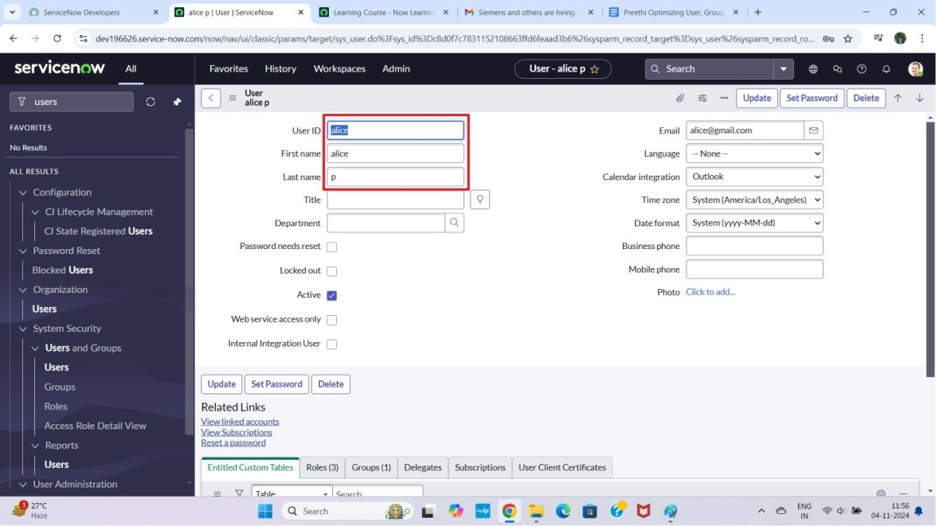

Create one more user :

* 1. Create another user with the following details
  2. Click on submit button.

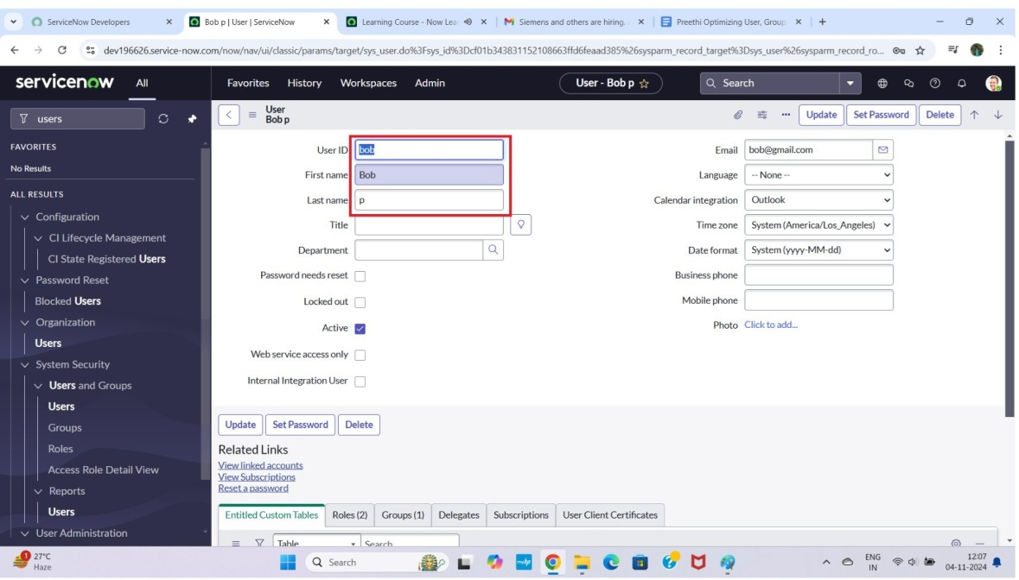

Milestone 2 : Groups Activity1 : Create Groups

1. Open service now.
2. Click on All>>search for groups
3. Select groups under system security
4. Click on new button
5. Then Fill the following details to create a new group
6. Click on submit Button

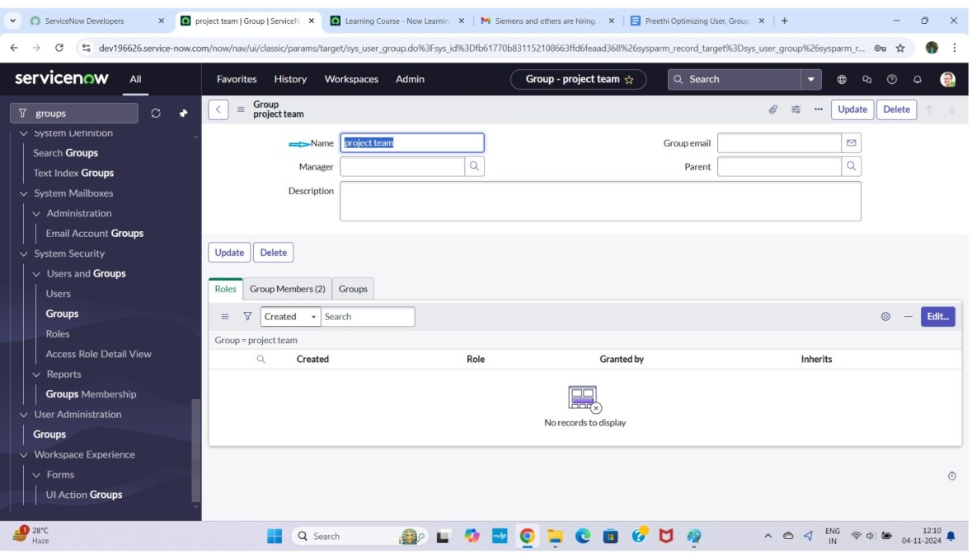

Milestone 3 : Roles Activity1 : Create roles

1. Open service now.
2. Click on All>>search for roles
3. Select roles under system security
4. Click on new button
5. Fill the following details to create a new role
6. Click on submit

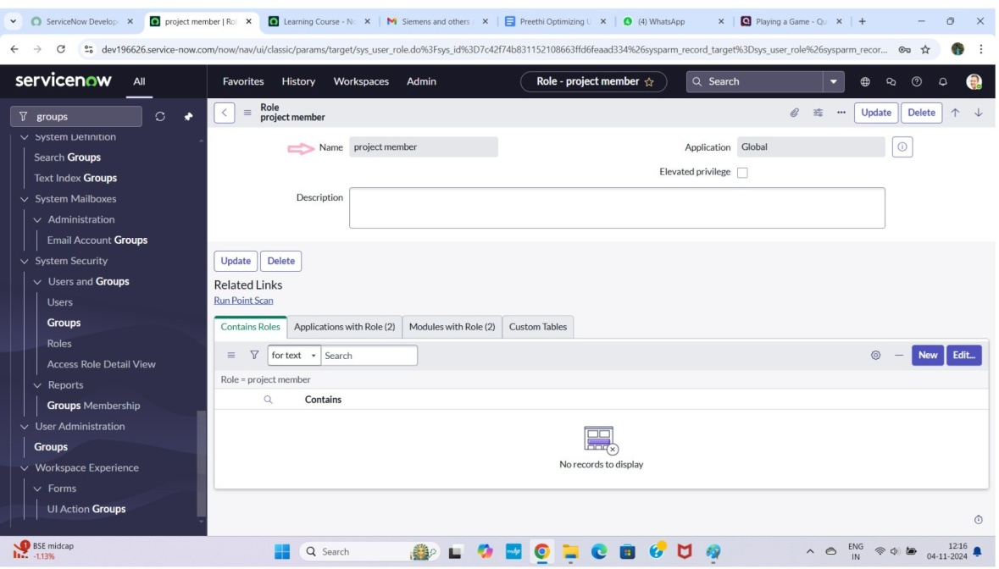

Create one more role :

1. Create another role with the following details
2. Click on submit

Milestone 4 : Table Activity 1 : Create Table

1. Open service now.
2. Click on All >> search for tables
3. Select tables under system definition
4. Click on new
5. Fill the following details to create a new table Label : project table

Check the boxes Create module & Create mobile module

1. Under new menu name : project table
2. Under table columns give the columns

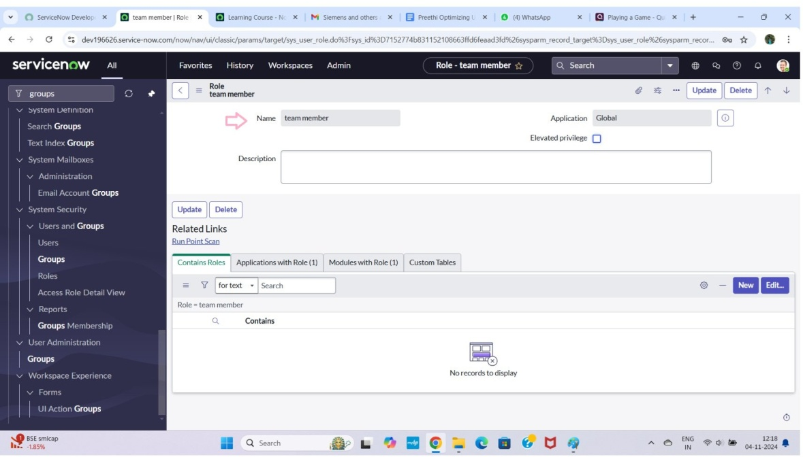

1. Click on submit

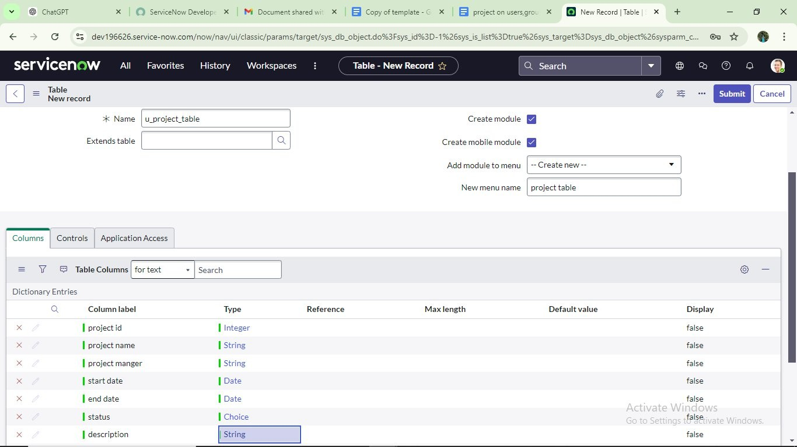

Create one more table :

1. Create another table as : task table 2 and fill with following details.
2. Click on submit.

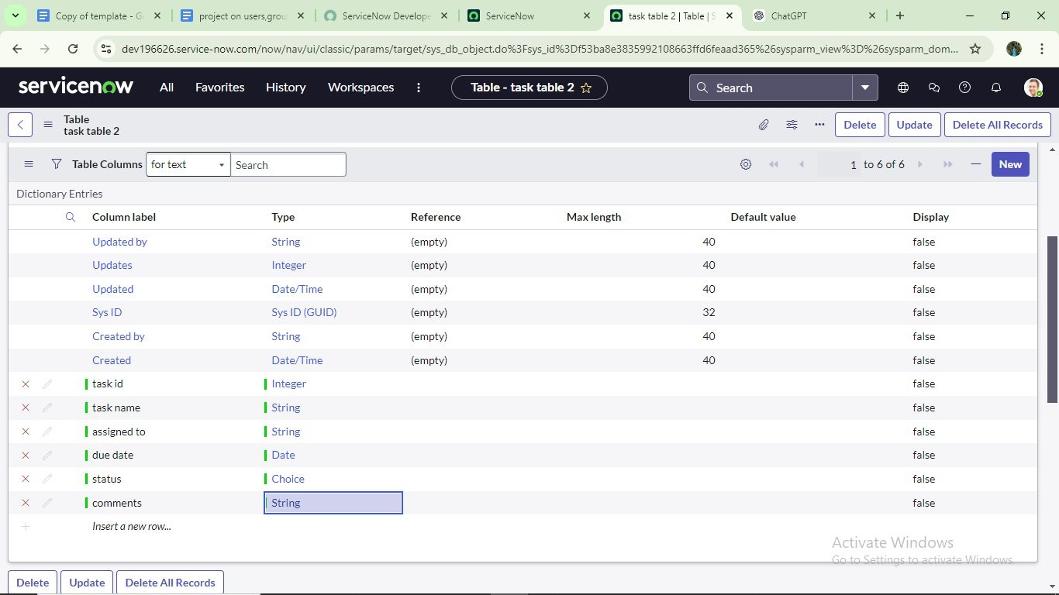

Milestone 5 : Assign users to groups

**Activity1 : Assign users to project team group**

* 1. Open service now.
  2. Click on All >> search for groups
  3. Select tables under system definition
  4. Select the project team group
  5. Under group members
  6. Click on edit
  7. Select alice p and bob p and save

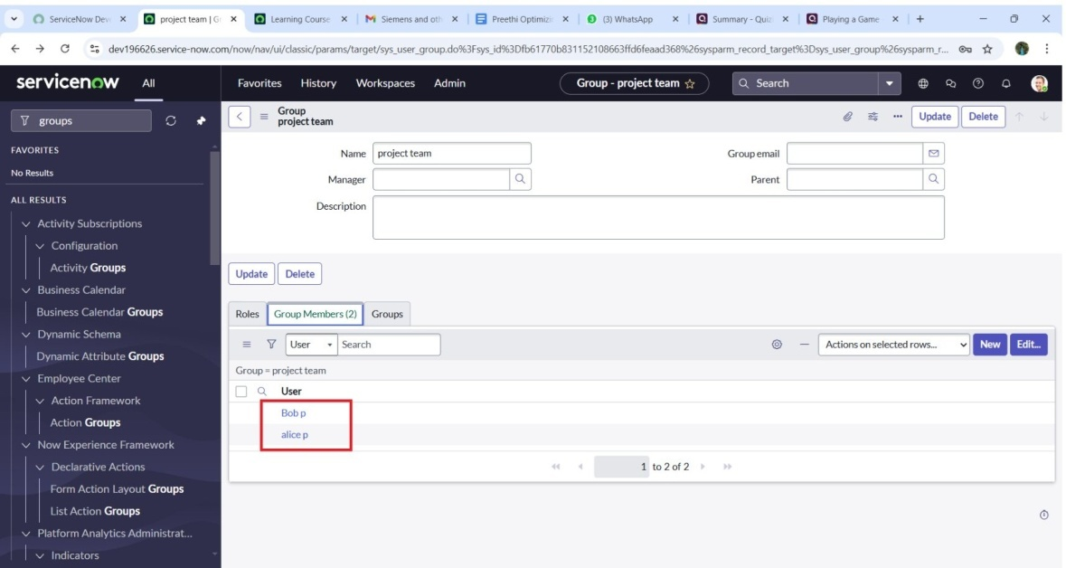

Milestone 6 : Assign roles to users Activity1 : Assign roles to alice user

1. Open service now. Click on All >> search for user
2. Select tables under system definition
3. Select the project manager user
4. Under project manager
5. Click on edit
6. Select project member and save
7. Click on edit add u project table role and u task table role
8. Click on save and update the form.

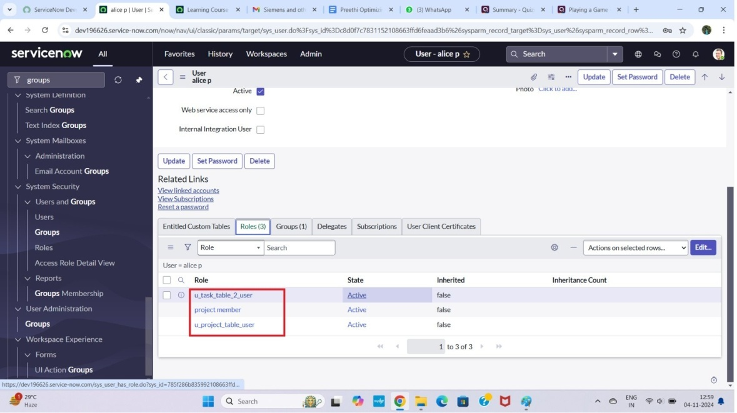

Activity 2 : Assign roles to bob user

1. Open service now. Click on Al l>> search for user
2. Select tables under system definition
3. Select the bob p user
4. Under team member
5. Click on edit
6. Select team member and give table role and save
7. Click on profile icon Impersonate user to bob
8. We can see the task table 2.

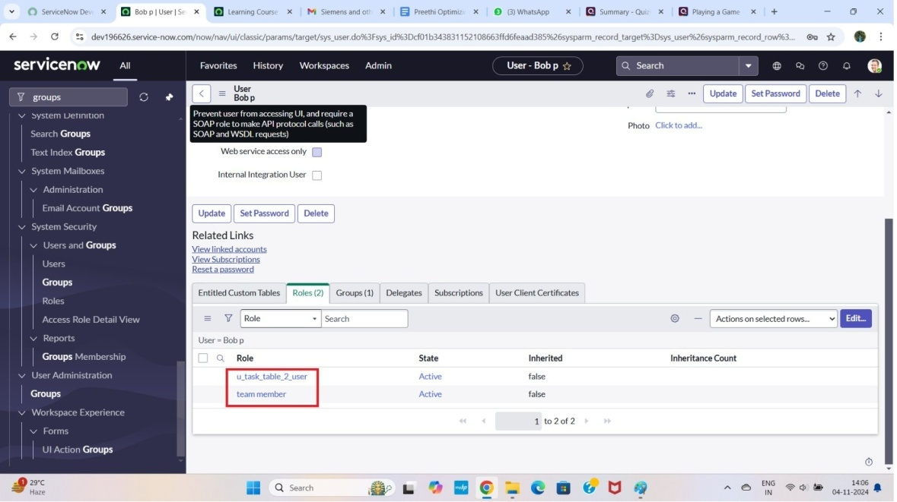

Milestone 7 : Application access

**Activity1 : Assign table access to application**

1. While creating a table it automatically create application and module for that table
2. Go to application navigator search for search project table application
3. Click on edit module
4. Give project member roles to that application
5. Search for task table 2 and click on edit application.
6. Give the project member and team member role for task table 2 application

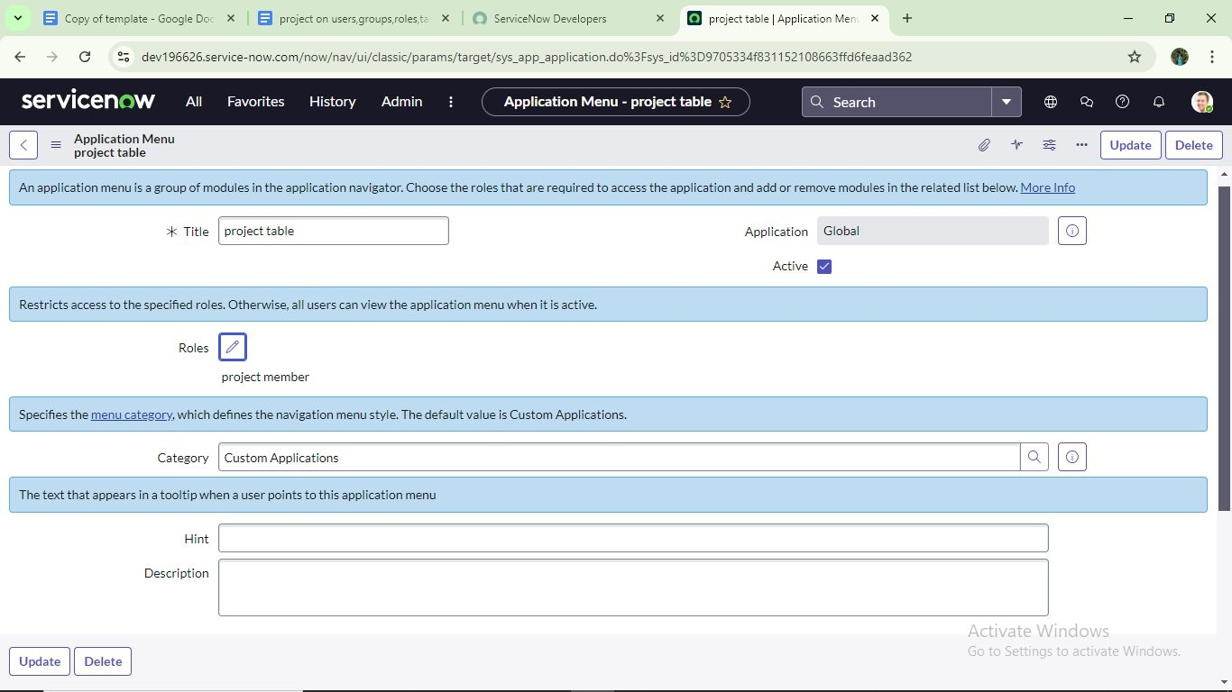

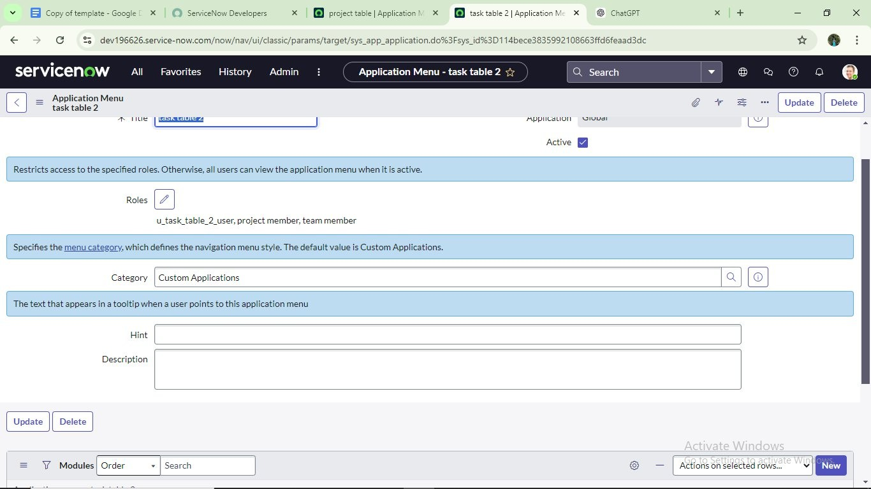

Milestone 8 : Access control list

**Activity 1 : Create ACL**

1. Open service now.
2. Click on All >> search for ACL
3. Select Access Control (ACL) under system security
4. Click on elevate role
5. Click on new

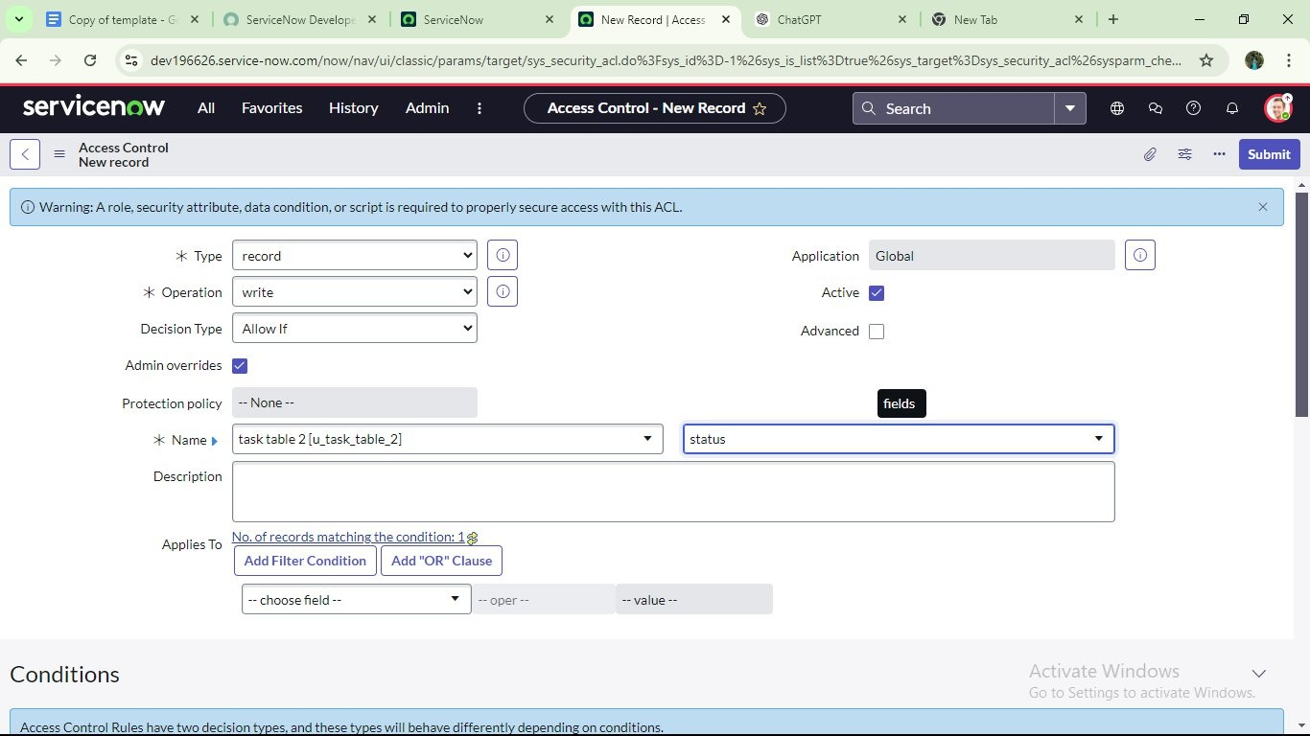

1. Fill the following details to create a new ACL
2. Scroll down under requires role
3. Double click on insert a new row
4. Give task table and team member role
5. Click on submit
6. Similarly create 4 acl for the following fields

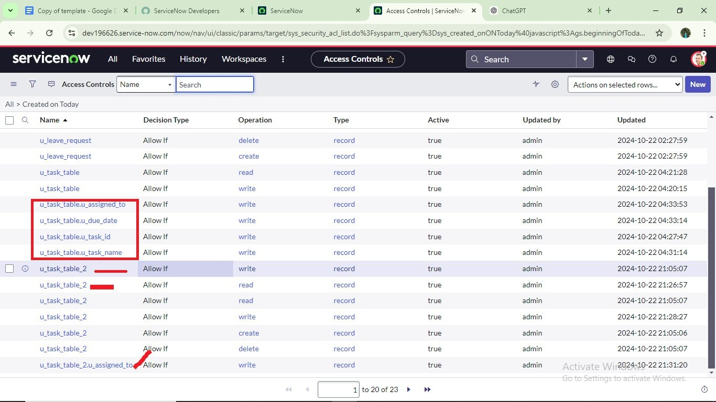

1. Click on profile on top right side
2. Click on impersonate user
3. Select bob user
4. Go to all and select task table 2 in the application menu bar
5. Comment and status fields are have the edit access

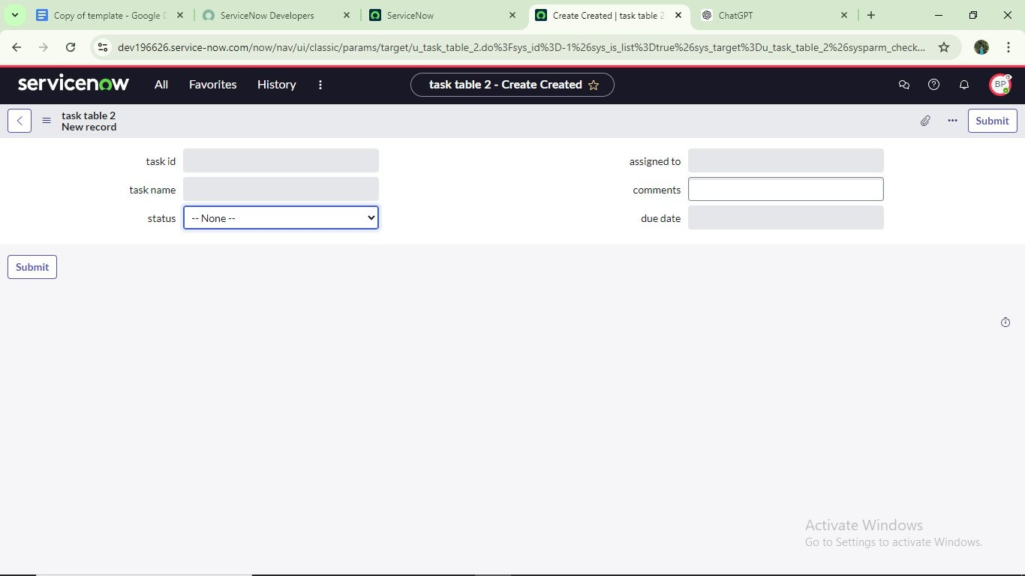

**Milestone 9 : Flow**

Activity 1 : Create a Flow to Assign operations ticket to group

1. Open service now.
2. Click on All >> search for Flow Designer
3. Click on Flow Designer under Process Automation.
4. After opening Flow Designer Click on new and select Flow.
5. Under Flow properties Give Flow Name as “task table”.
6. Application should be Global.
7. Click build flow.

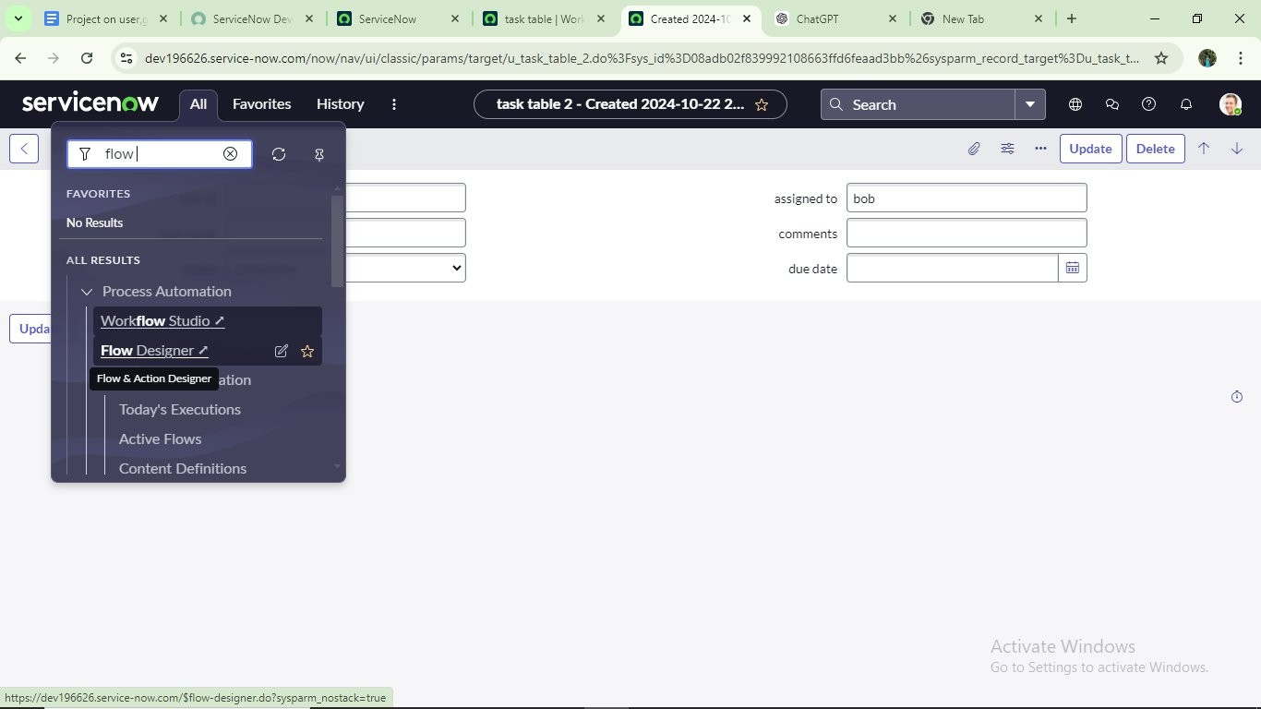

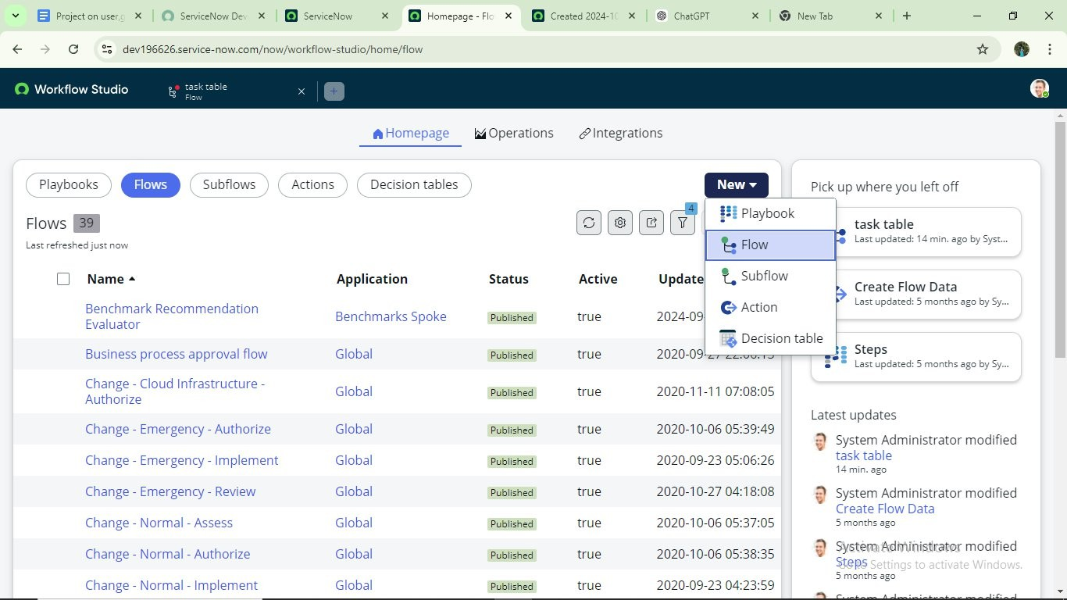

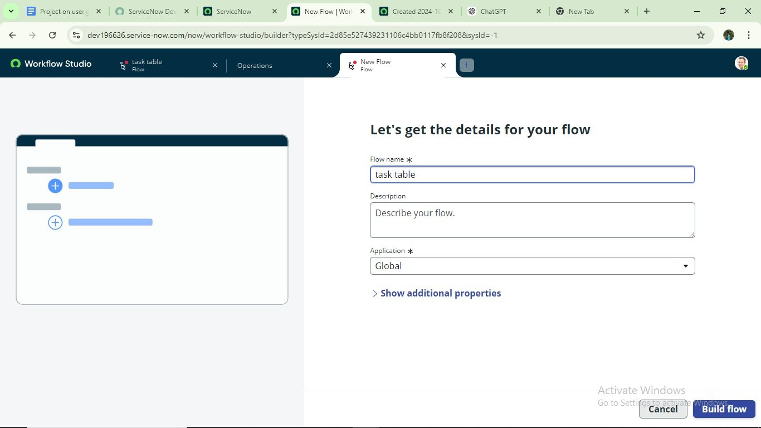

Next step :

1. Click on Add a trigger
2. Select the trigger in that Search for “create record” and select that.
3. Give the table name as “task table”.
4. Give the Condition as Field : status Operator : is Value : in progress

Field : comments Operator : is Value : feedback Field : assigned to Operator : is Value : bob

1. After that click on Done.

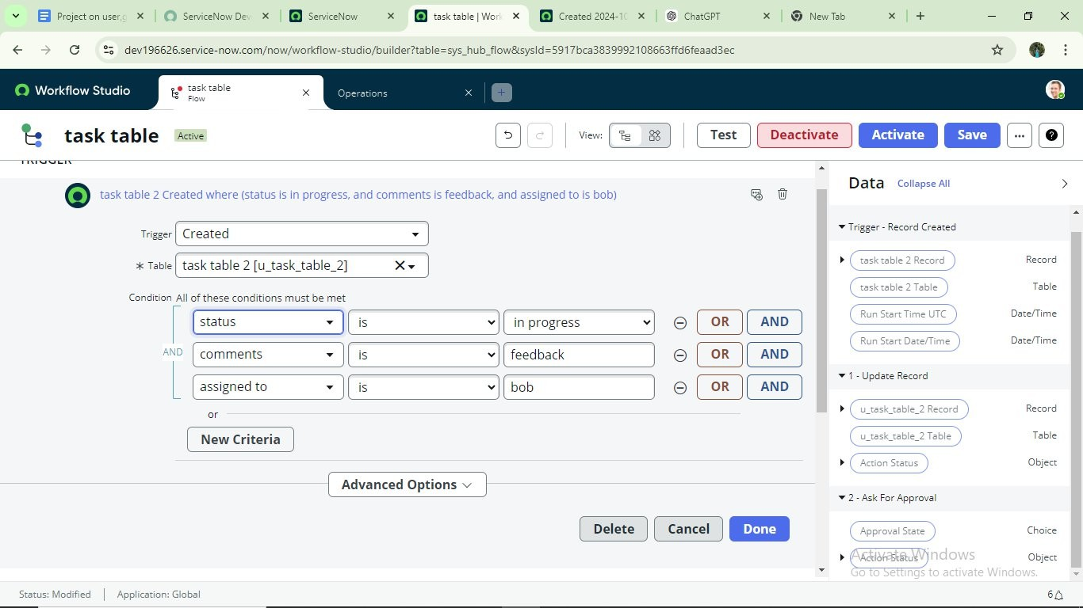

Next step :

1. Click on Add an action.
2. Select action in that, search for “update records”.
3. In Record field drag the fields from the data navigation from Right Side(Data pill)
4. Table will beau to assigned after that
5. Add fields as “status” and value as “completed”
6. Click on Done.

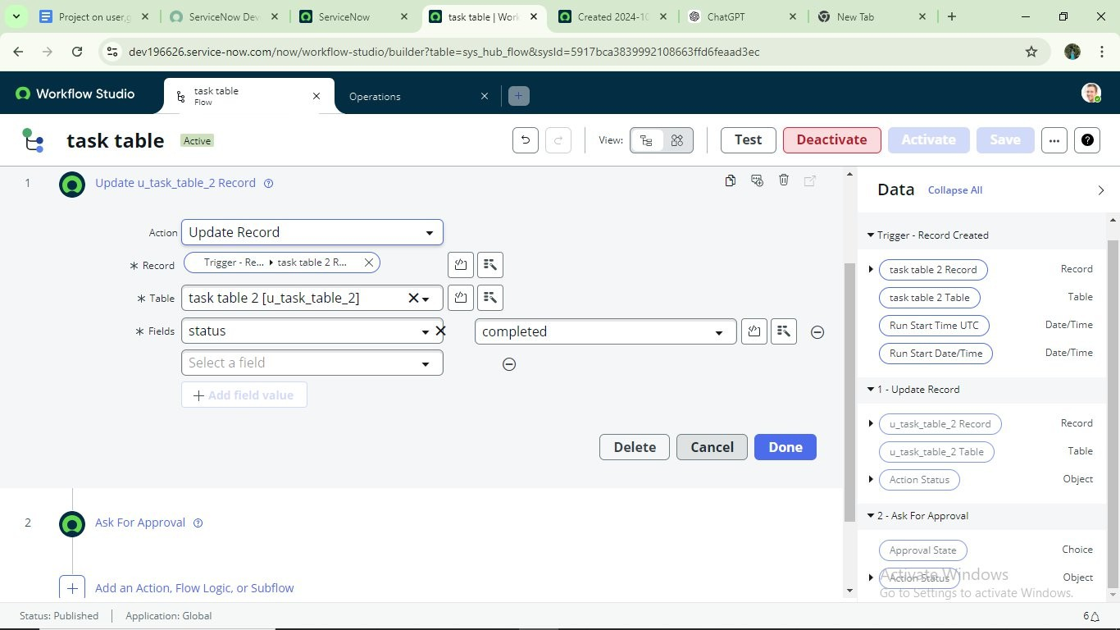

Next step :

1. Now under Actions.
2. Click on Add an action.
3. Select action in that, search for “ask for approval”.
4. In Record field drag the fields from the data navigation from Right side
5. Table will beau to assigned after that
6. Give the approve field as “status”
7. Give approver as alice p
8. Click on Done.

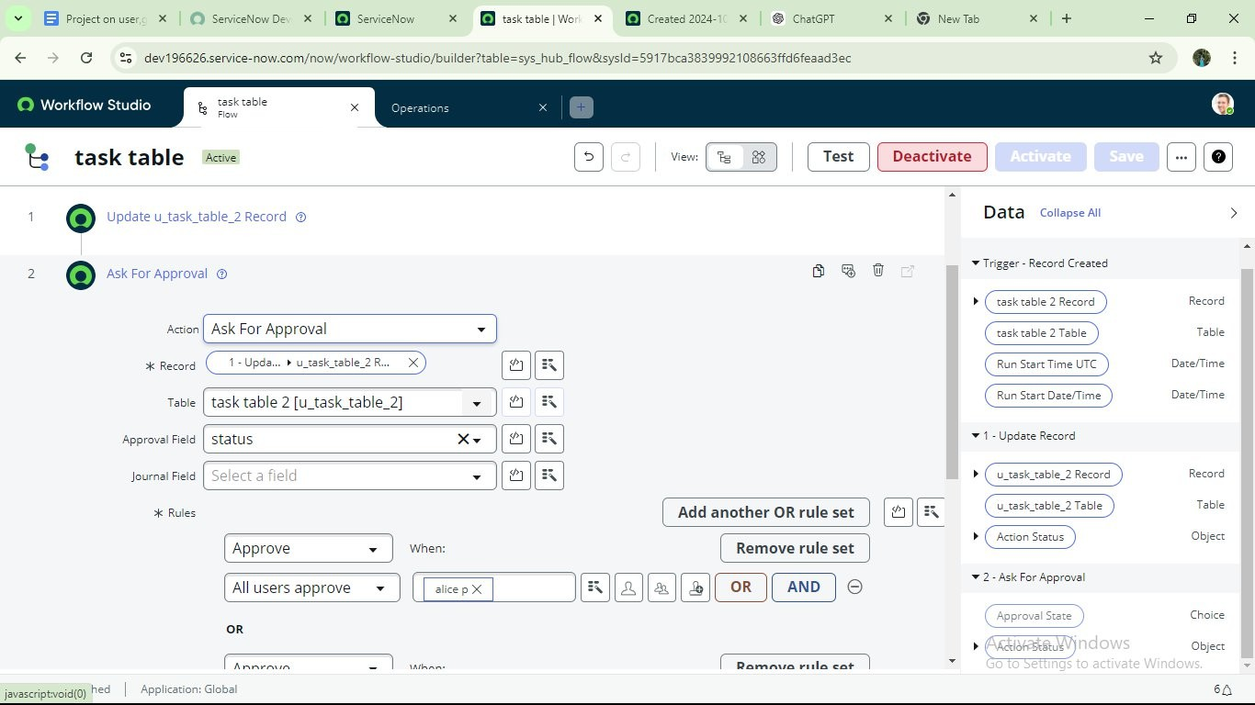

1. Go to application navigator search for task table.
2. It status field is updated to completed

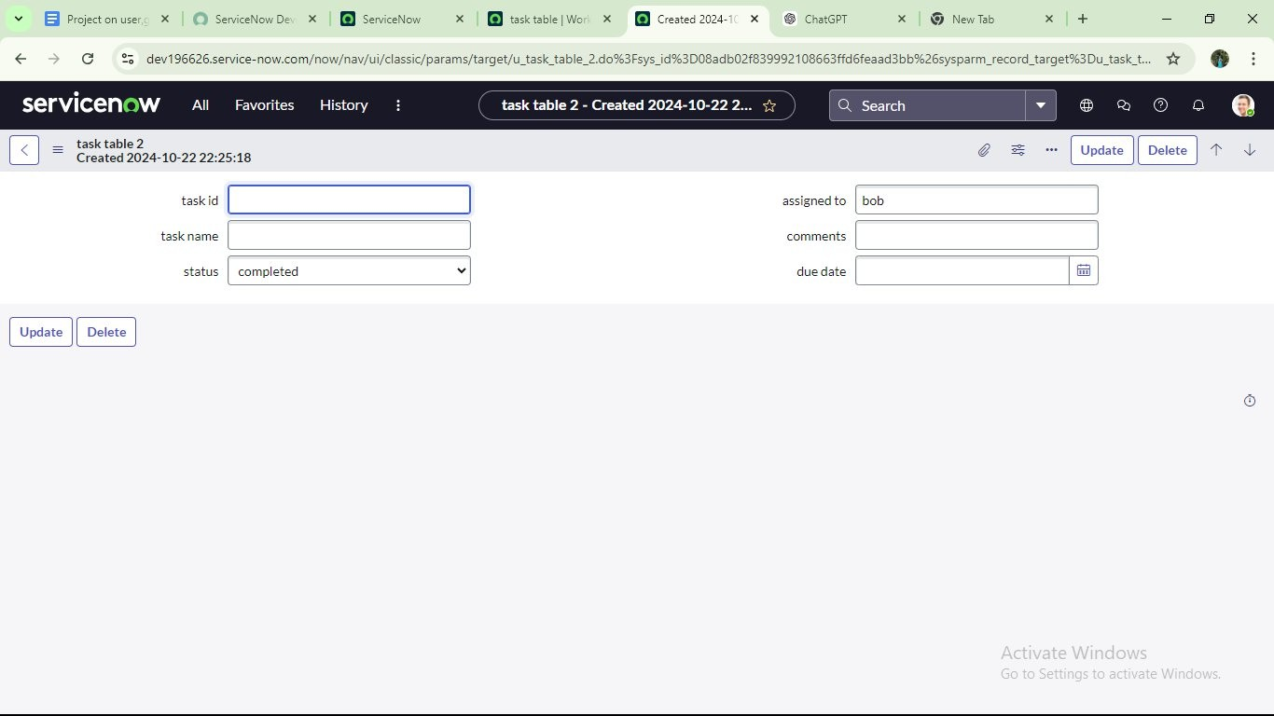

1. Go to application navigator and search for my approval
2. Click on my approval under the service desk.
3. Alice p got approval request then right click on requested then select approved

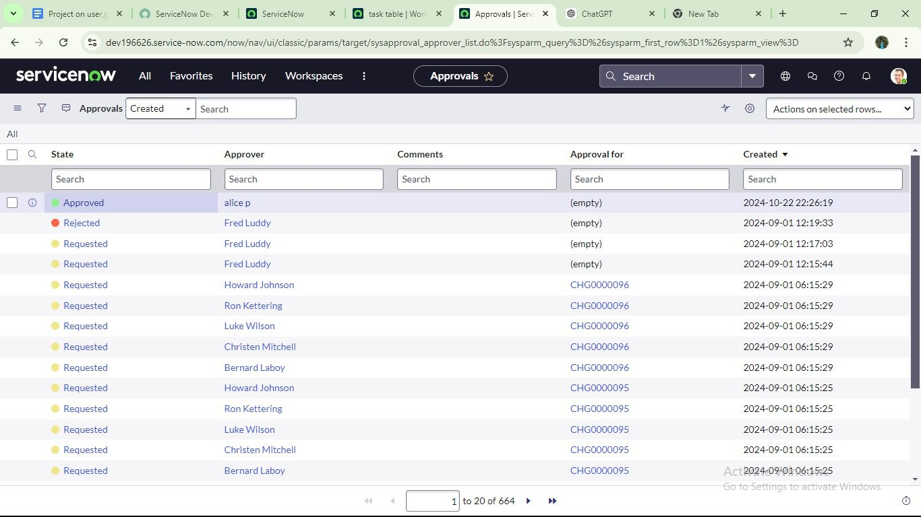

Conclusion:

This scenario highlights a structured approach to project management, show casing the roles of Alice and Bob with in a defined workflow. With Alice's over sight and Bob's execution, the team effectively collaborates to ensure project success. The use of tables organizes key information, facilitating easy tracking of projects, tasks, and progress updates. Overall, this system promotes accountability, enhances communication, and leads to the successful completion of projects.

Tab 2